Anti-Theft Smart Locker System Using ESP32

Abstract
The proposed system provides reliable intrusion detection, real-time alerting, and automated asset protection through an intelligent hidden-compartment mechanism.
Group Member Details
ESP32, Embedded System, IoT, Smart Locker, Security System

INTRODUCTION
In contemporary living, security of personal property is of the utmost importance. Many individuals keep jewelry, money, documents and electronic devices in lockers; assuming complete security. Current locker models only have basic mechanisms for locking and do not provide real-time monitoring of the use of the locker.
With the rapid advancement of Internet of Things (IoT) and embedded technologies, traditional security systems can be transformed into intelligent and automated protection systems. Smart lockers can authenticate users, detect intrusion attempts, trigger alarms, and transmit real-time notifications through internet-based communication.
In this project, an ESP32 will be utilized as a central controller which will handle the authentication process, detect theft attempts and trigger alarms for a single user. The ESP32 microcontroller is ideal for these applications due to its integrated Wi-Fi capability, processing speed and multiple sensor interfaces.
A microcontroller is a compact programmable integrated circuit used to control electronic systems. An embedded system is a dedicated computing system designed for a specific function.
Security is a major concern in modern environments. Traditional lockers lack intelligent monitoring and fail to provide real-time alerts. This project introduces a smart locker system using ESP32that integrates authentication, sensing, and communication technologies.
The system detects unauthorized access and secures valuables using a hidden compartment, making it more advanced than conventional lockers.

LITERATURE REVIEW
- Sudha Kousalya, G. Reddi Priya, R. Vasanthi, and B. Venkatesh (2018) presented an IoT-based smart security and home automation system using Arduino and sensors. Their system focused on real-time monitoring, remote control, and automation using internet communication. The research demonstrated how embedded systems can improve security and convenience in modern environments. Their work also emphasized the importance of low-cost IoT-based smart security solutions.
- Mohamed Faisal Elrawy, Ali Ismail Awad, and Hesham F. A. Hamed (2018) discussed intrusion detection systems for IoT-based smart environments. Their study highlighted threats such as unauthorized access, malware attacks, and insecure communication in connected systems. The researchers proposed secure authentication and communication mechanisms to improve IoT security and reliability.
- Muhammad Burhan, Rana Asif Rehman, Bilal Khan, and Byung-Seo Kim (2018) proposed layered IoT architectures and analyzed vulnerabilities in cloud-connected embedded devices. Their research focused on scalability, secure communication, and interoperability in IoT systems. The study emphasized the need for strong protection mechanisms in smart connected environments.
- Kejun Chen, Shuai Zhang, Zhikun Li, and Yier Jin (2018) investigated security threats and vulnerabilities in Internet of Things applications. Their study discussed malware attacks, privacy issues, and unauthorized access in smart systems. The researchers also proposed security countermeasures to improve data protection and system reliability.
- Aditya Kumar, Shipra Saraswat, and Saurabh Singh (2018) developed a laser-based IoT security system using Arduino and infrared sensors. Their system detected intrusion attempts and generated real-time alerts using internet communication. The project demonstrated an affordable and efficient embedded security solution for smart environments.
- T. Pavan Kumar, R. Hemanth Krishna, M. Sai Krishna, and Jhanavi Meghana (2018) implemented a smart home automation system integrated with IoT communication and sensor monitoring. Their research focused on remote control, automation, and security enhancement using embedded technologies. The study showed the effectiveness of IoT in intelligent monitoring systems.
- Deepti Sehrawat and Nasib Singh Gill (2018) analyzed major challenges in IoT deployment including scalability, privacy, security, and communication reliability. Their work highlighted the importance of secure data transfer and efficient network management in smart environments. The study provided insights into limitations and future improvements in IoT systems.
- Imran Makhdoom, Mehran Abolhasan, Justin Lipman, and Ren Ping Liu (2018) explored cyber threats and security challenges in IoT systems. Their research discussed secure communication methods, encryption techniques, and authentication systems for protecting smart devices. The study emphasized the importance of cybersecurity in embedded and IoT applications.
- Amit Kumar Sikder, Giuseppe Petracca, Hidayet Aksu, Trent Jaeger, and A. Selcuk Uluagac (2018) surveyed sensor-based attacks in IoT systems and discussed vulnerabilities associated with embedded sensors. Their work proposed security mechanisms to improve sensor reliability and prevent unauthorized access in smart devices.
- Vishal Sharma, Ilsun You, Karl Andersson, and Francesco Palmieri (2019) studied trust management, privacy protection, and secure communication techniques for IoT-based mobile systems. Their research focused on authentication methods, secure data exchange, and cloud-connected applications. The study contributed toward improving reliability and security in IoT communication networks.

PROBLEM STATEMENT
Traditional locker systems suffer from several limitations:
- No real-time monitoring or alert mechanism
- Keys can be lost, duplicated, or easily compromised
- No intrusion detection for unauthorized access attempts
- No remote notification system for the owner
- Delayed response during theft or tampering incidents
- No fallback system on breach
Therefore, an intelligent security solution is required that can automatically detect suspicious activity, notify the user in real time, and protect valuables more effectively.

OBJECTIVES
- To design a smart locker system using ESP32
- To implement password-based authentication
- To detect unauthorized access using a vibration sensor
- To generate real-time theft alerts through IoT communication
- To activate a hidden safety compartment during intrusion attempts
- To develop a web-based monitoring dashboard
- To enhance security compared to conventional lockers

SYSTEM DESIGN

Methodology of Model Development
Methodology is a structured approach used to design and implement a system.
Steps:
- Password input via keypad
- Validation by ESP32
- Servo control for locking
- Vibration detection
- Alert triggering
- Telegram and Web notification

Hardware Module Design
The proposed Anti-Theft Smart Locker System consists of multiple hardware modules integrated to provide authentication, intrusion detection, automated locking, and IoT-based monitoring.
The ESP32 microcontroller acts as the central controller of the system. It processes sensor data, validates passwords, controls output devices, and manages Wi-Fi communication.
A 4x4 keypad is used for password entry, while a servo motor controls the locking and unlocking mechanism of the locker. The SW-420 vibration sensor detects tampering or forced access attempts and sends signals to the ESP32 for security action.
A 16x2 LCD display with an I2C module is used to display system messages and authentication status. A buzzer generates alarm sounds during unauthorized access attempts.
All components are connected using jumper wires to form a compact and intelligent embedded security system.

Block Diagram
A block diagram is a graphical representation of the system components. It is a high-level visual representation of a system, using labeled rectangles (blocks) to represent major components or functions and lines to show their relationships, signal flow, or interactions. Focuses on the general structure and functionality, rather than detailed technical implementation.
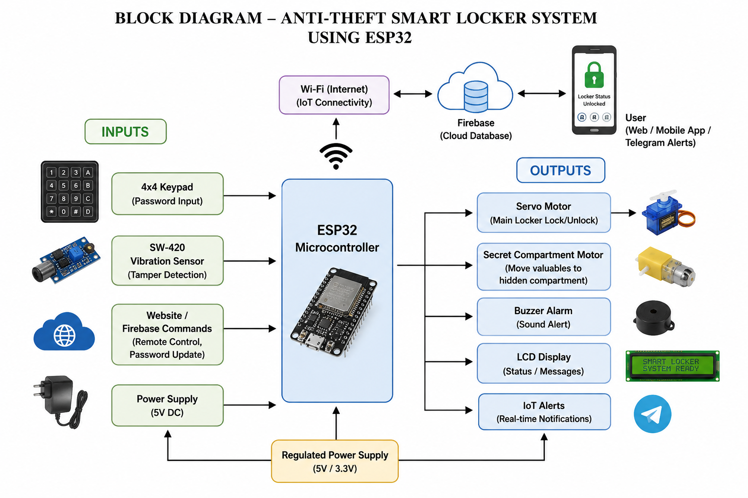
Block Diagram
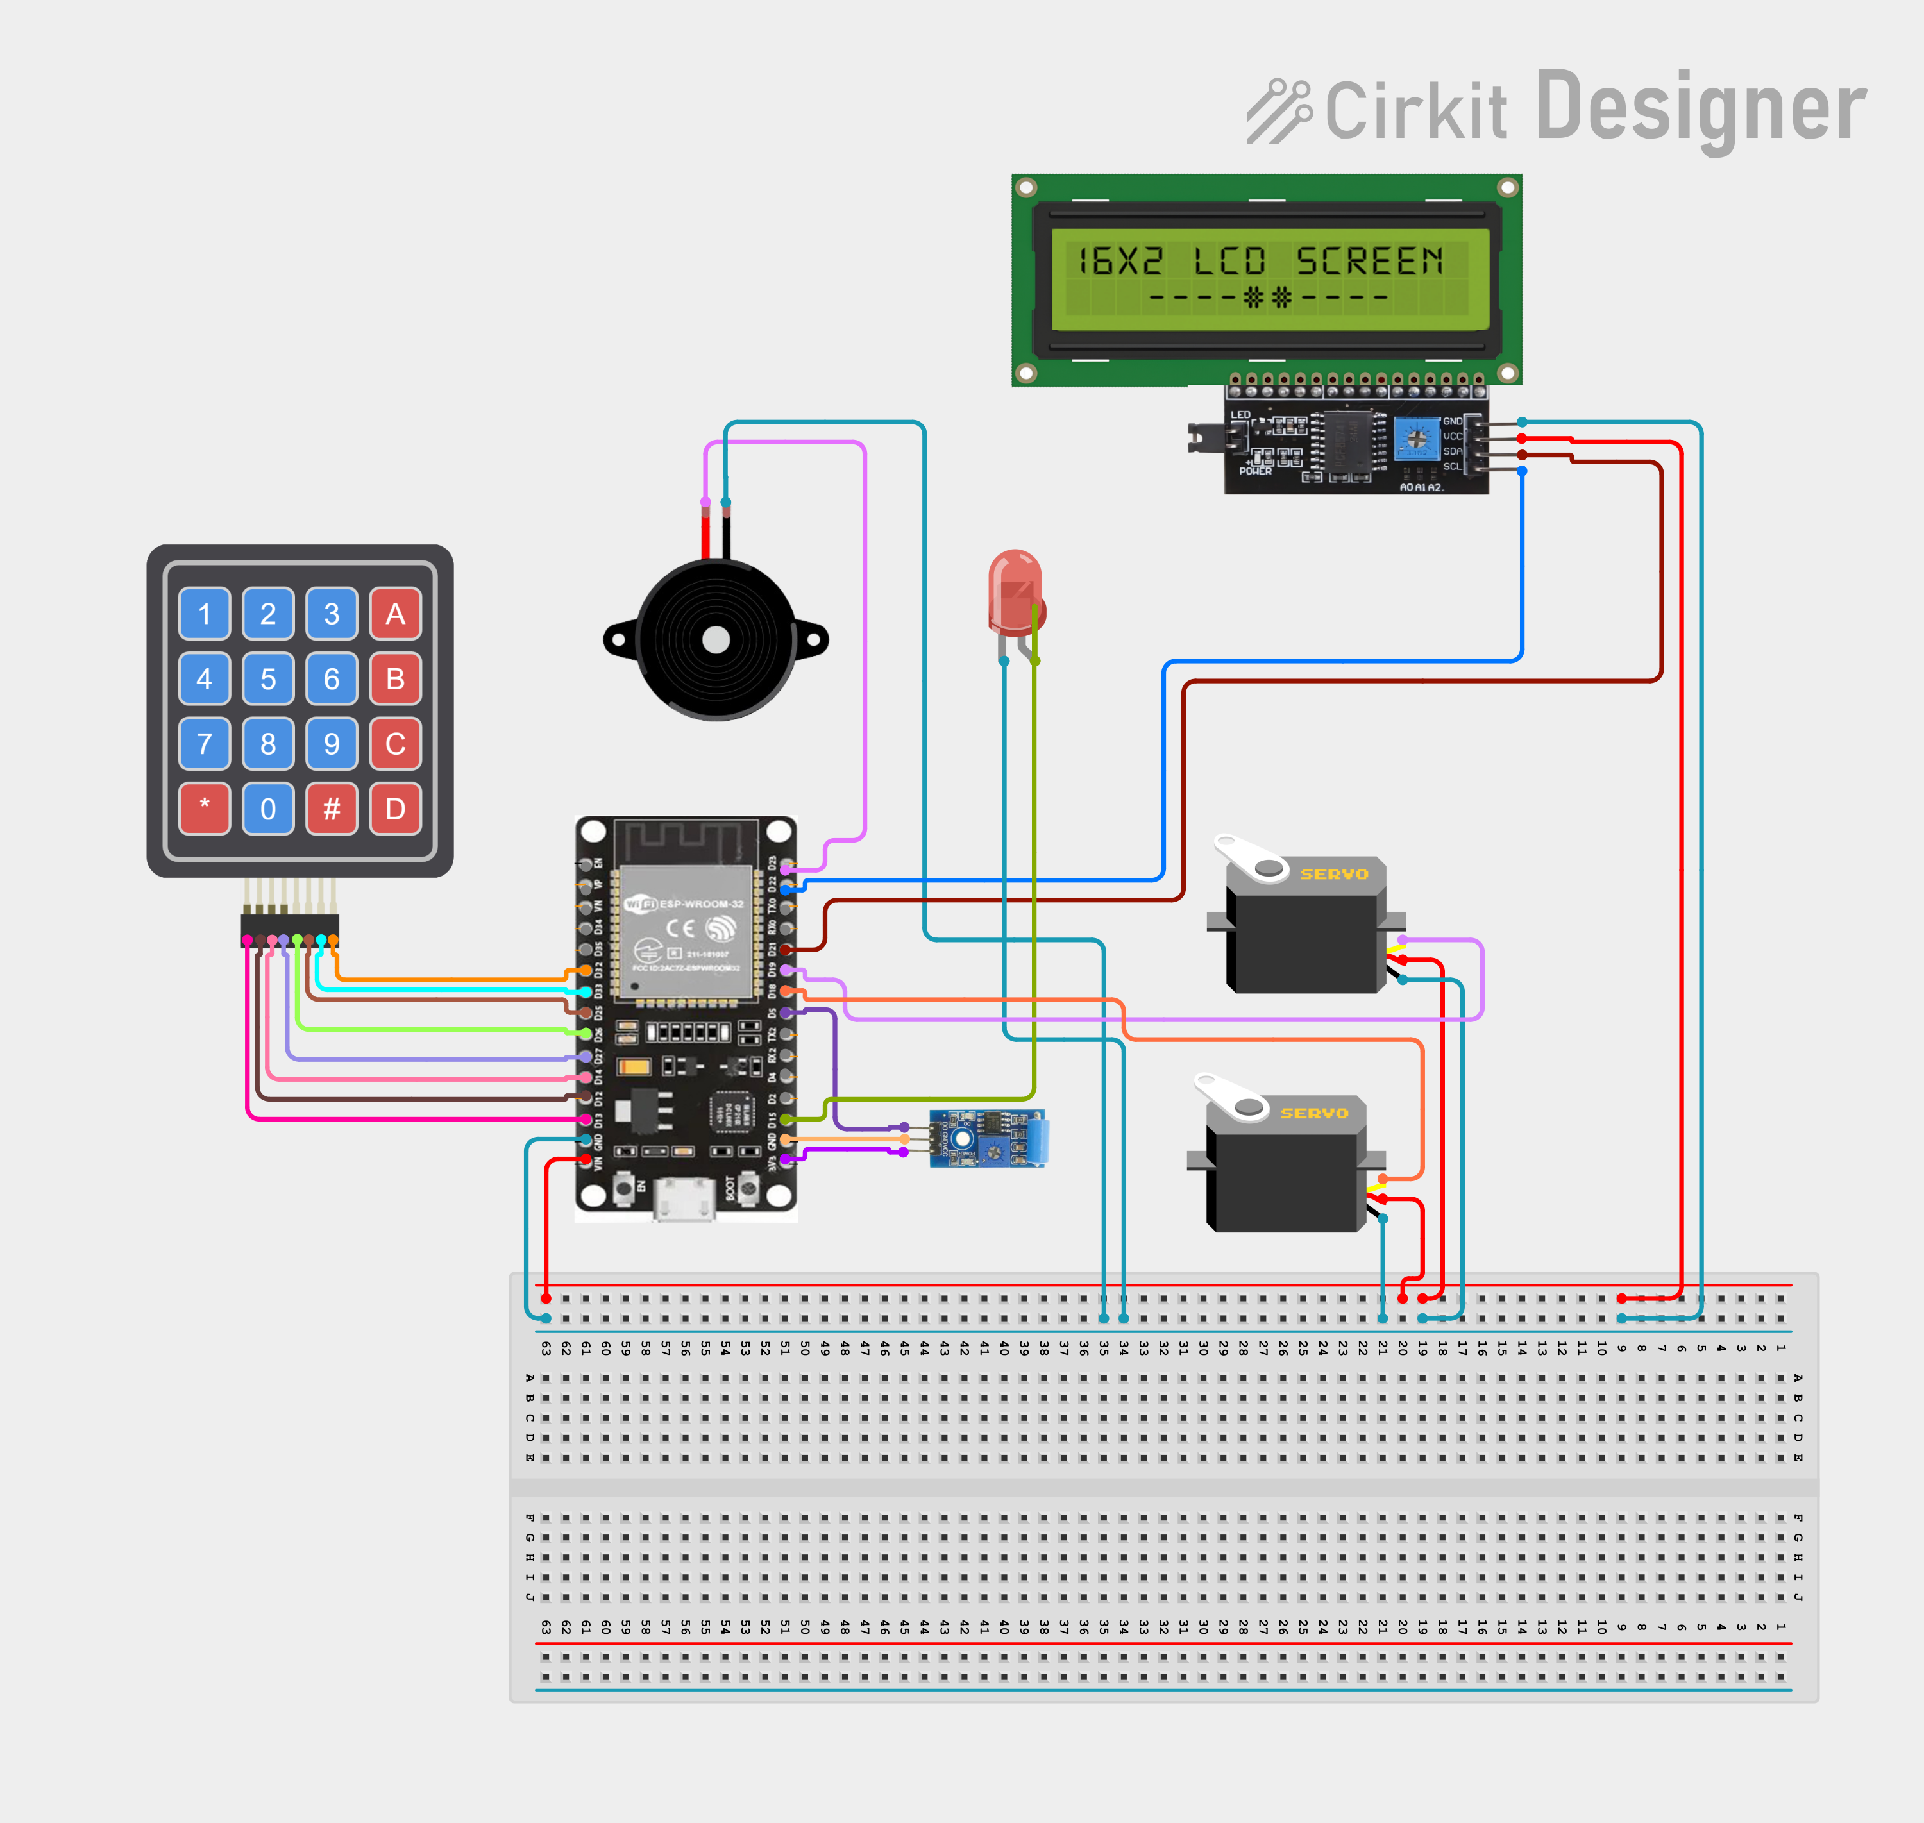
Circuit Diagram of Smart Locker System

HARDWARE DESCRIPTION

ESP32
ESP32 is a highly capable microcontroller that integrates Wi-Fi as well as Bluetooth (BLE). This device provide many GPIOs (input/output pins), low power consumption, as well as fast performance and can also be used to control all the sensors attached to an output device within a single system.
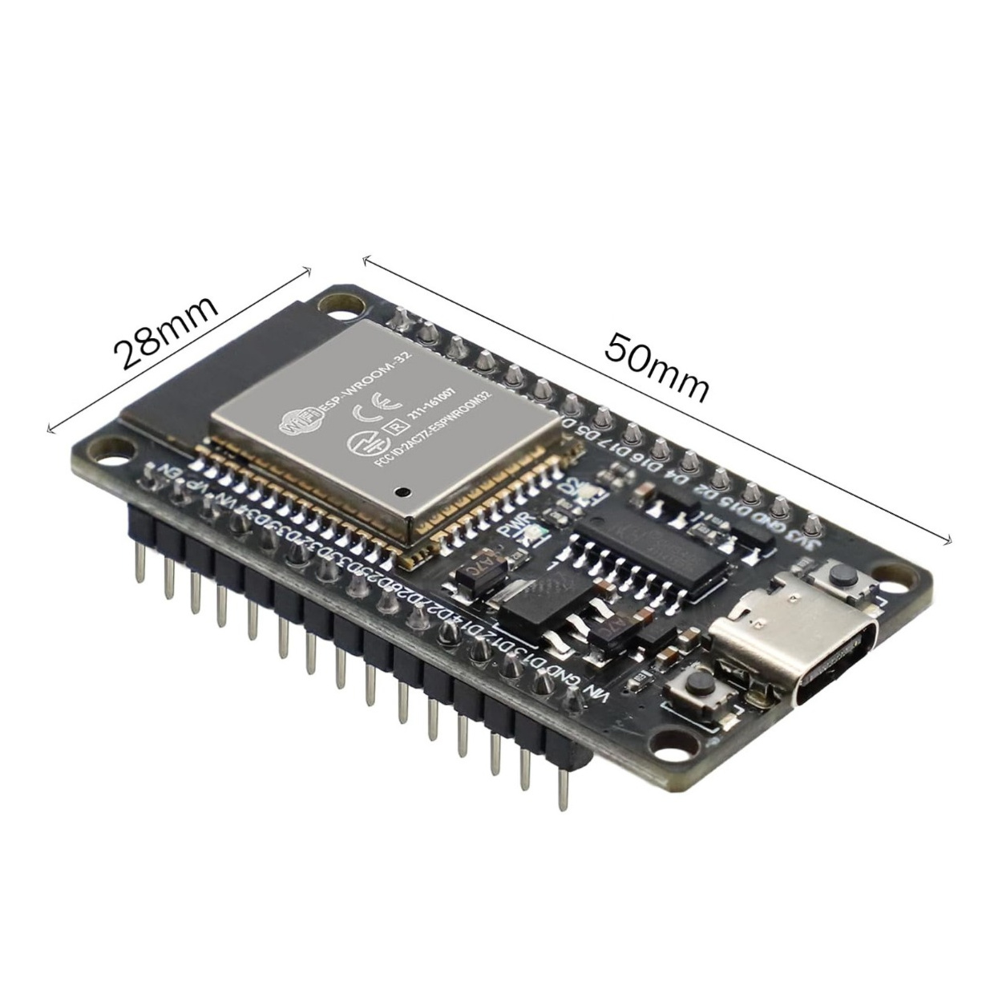
ESP32 Module

Keypad
A keypad is an input device that is used to enter passwords. It is a peripheral input device utilized in embedded systems to capture alphanumeric user input. It provides a highly efficient method for integrating multiple tactile switches into a circuit while minimizing the hardware resources required from the host microcontroller, such as an Arduino or ESP32.
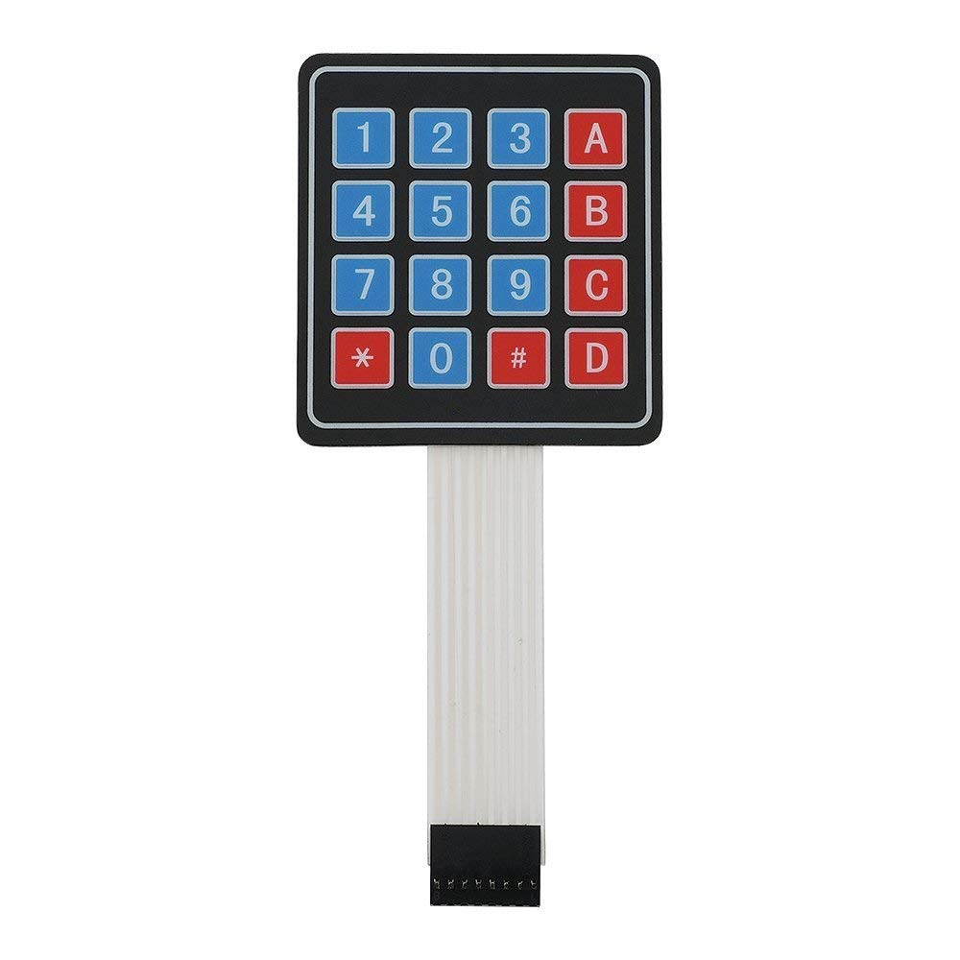
4x4 Keypad

Servo Motor
The Servo Motor is a high-precision rotary actuator designed for accurate control of angular position, velocity, and acceleration. Unlike standard DC motors that rotate continuously, a servo is engineered for applications where specific positioning is critical.
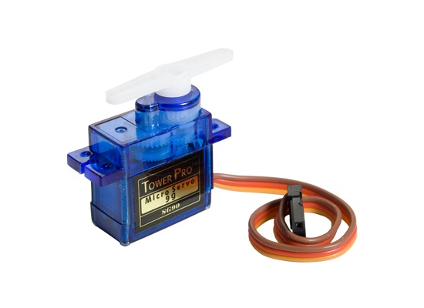
Servo Motor

Vibration Sensor
SW-420 Vibration Sensor is a module that can detect vibrations or shocks on a surface. It can be used for various purposes, such as detecting door knocks, machine malfunctions, car collisions, or alarm systems. It operates from 3.3 V to 5 V. The module has three peripherals, two LEDs, one for the power status and the other for the sensor output. In addition, there is a potentiometer that can be further used to control the threshold point of the vibration.
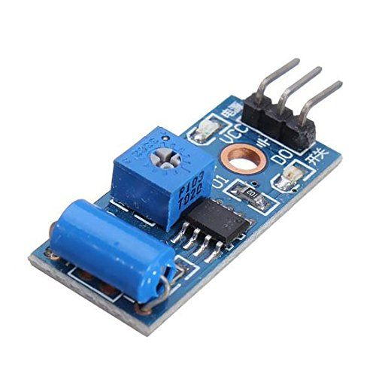
Vibration Sensor (SW-420)

LCD Display
A 16x2 LCD is a basic, affordable, and widely used Liquid Crystal Display module capable of showing 32 alphanumeric characters across two rows, with 16 characters per row
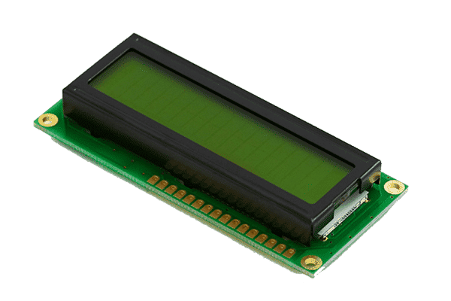
16x2 LCD

I2C Module
An I2C Module enables communication with microcontrollers like Arduino or ESP32 using only two data pins (SDA and SCL) instead of the 10+ wires required for parallel mode.
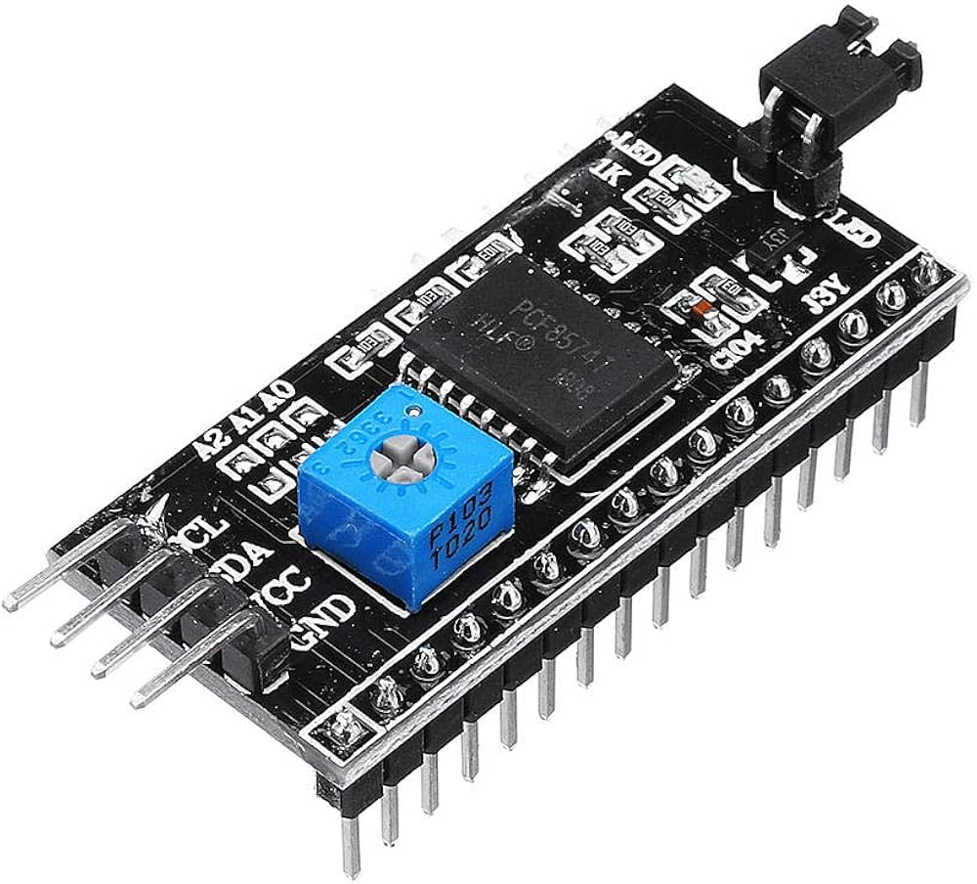
I2C Module

Jumper Wires
Jumper wires are flexible electrical cables used in electronics. They have connectors at both ends and are often made of thin copper wire with insulation. They’re handy for creating temporary connections between components on breadboards or circuit boards during testing or prototyping.
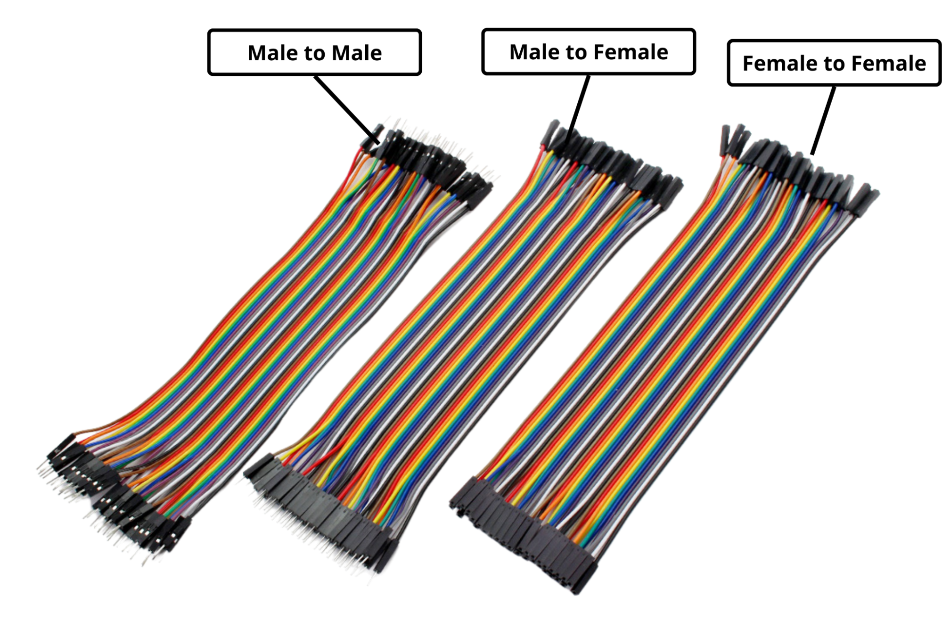
Jumper Wires (M2M, F2F, M2F)

HARDWARE WORKING
The system works by combining input, processing, and output. When a password is entered, ESP32 validates it. If correct, the servo unlocks the locker. If incorrect, attempts increase and an alert is triggered after 3 failures. If unauthorized vibration or tampering is detected, the buzzer alarm is activated and the secret compartment mechanism secures the valuables automatically.

SOFTWARE OVERVIEW
An IDE (Integrated Development Environment) is software used to develop programs.
The software implementation is developed using Arduino IDE with libraries including Keypad, ESP32Servo, WiFi, HTTPClient, and LiquidCrystal I2C for hardware interfacing and IoT communication.
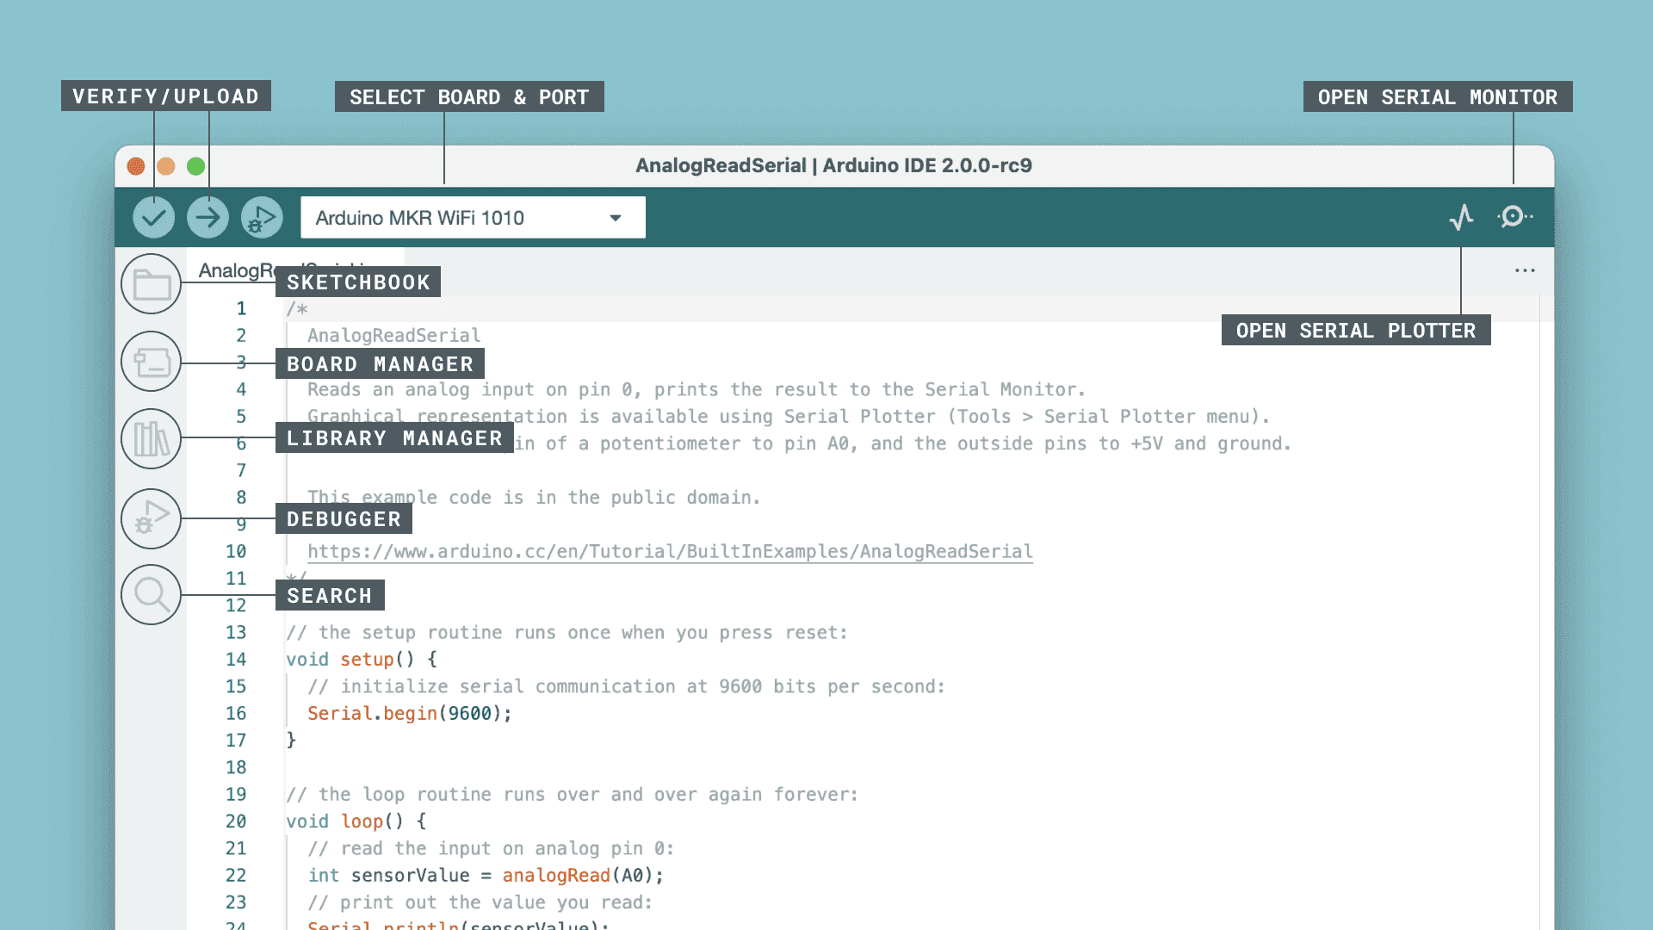
Arduino IDE

SOFTWARE IMPLEMENTATION
The software implementation of the proposed Anti-Theft Smart Locker System is developed using the ESP32 microcontroller, Firebase Realtime Database, and a React-based web application. The software controls authentication, intrusion detection, IoT communication, cloud synchronization, and real-time monitoring.
The ESP32 acts as the central processing unit of the system. It continuously reads sensor inputs, validates password data, controls actuators, and exchanges real-time information with the cloud database through Wi-Fi communication.
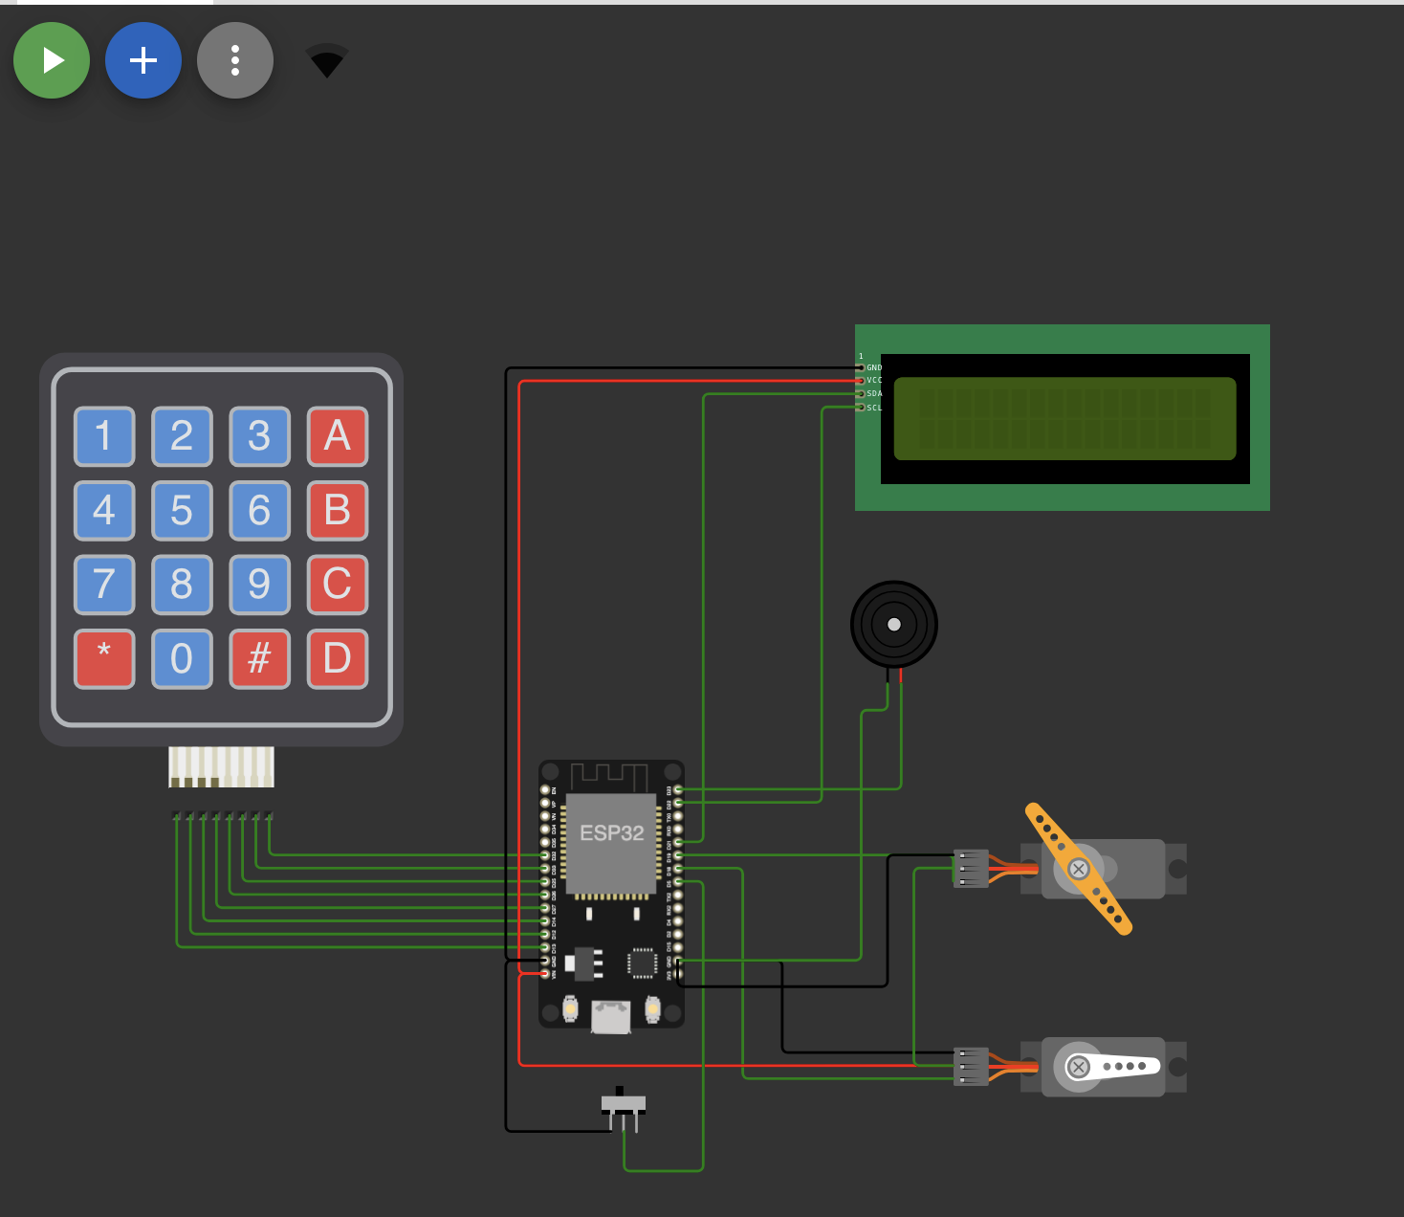
Simulation of Smart Locker System

System Workflow
The complete software workflow operates as follows:
- The system initializes all peripherals including the keypad, LCD display, servo motor, vibration sensor, buzzer, and Wi-Fi module.
- The user enters the password using the 4×4 matrix keypad.
- The ESP32 compares the entered password with the stored password data.
- If the password is correct:
  - The servo motor unlocks the locker.
  - Access is granted to the user.
  - The LCD displays a success message.
  - System status is updated on the web dashboard.
- If the password is incorrect:
  - The attempt counter increases.
  - Warning messages are displayed on the LCD.
  - Unauthorized activity is logged in the cloud database.
- After three incorrect attempts:
  - The buzzer alarm is activated.
  - The secret compartment mechanism is triggered.
  - Real-time theft alerts are sent through Telegram/web dashboard notifications.
  - The system enters theft protection mode.
- 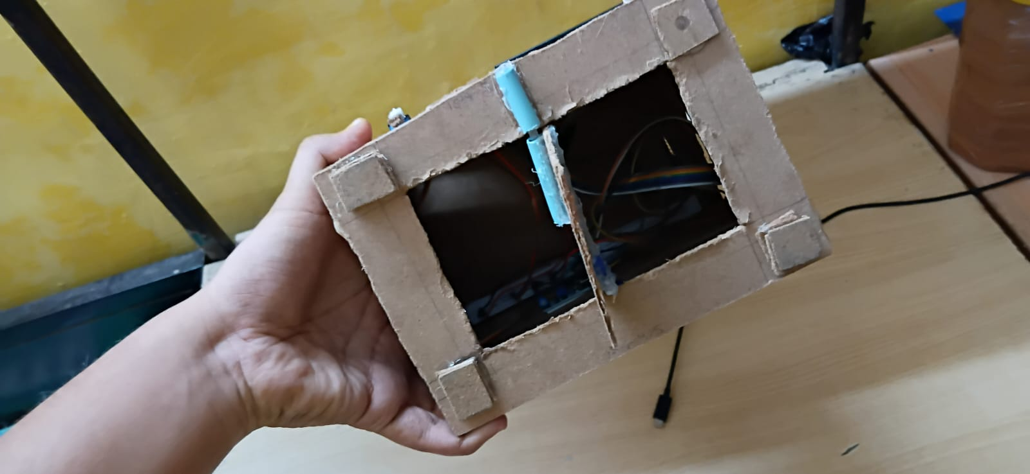
- Hidden Safety Compartment Mechanism
- The SW-420 vibration sensor continuously monitors physical tampering and forced break-in attempts.
- If strong vibration or impact is detected:
  - The alarm system is activated immediately.
  - Emergency security actions are executed.
  - Alert data is transmitted to Firebase.
- The React web application provides:
  - Real-time locker status monitoring
  - Remote password management
  - Intrusion alert visualization
  - Cloud-connected system monitoring
  - Live synchronization with ESP32

Technologies Used
- ESP32 — Main microcontroller responsible for embedded processing and Wi-Fi communication.
- Arduino IDE — Development platform used for programming and uploading firmware to ESP32.
- Firebase Realtime Database — Cloud database used for real-time data synchronization and remote monitoring.
- React.js — Frontend framework used to develop the interactive web dashboard.
- HTTP Protocol — Communication protocol used for data transfer between ESP32 and cloud services.
- Embedded C/C++ — Programming language used for hardware-level control and logic implementation.

Web Dashboard
The web-based dashboard provides a user-friendly interface for remote monitoring and control of the locker system. The dashboard displays locker status, intrusion alerts, authentication activity, and cloud-connected updates in real time. It also allows password management and remote system interaction through internet connectivity.
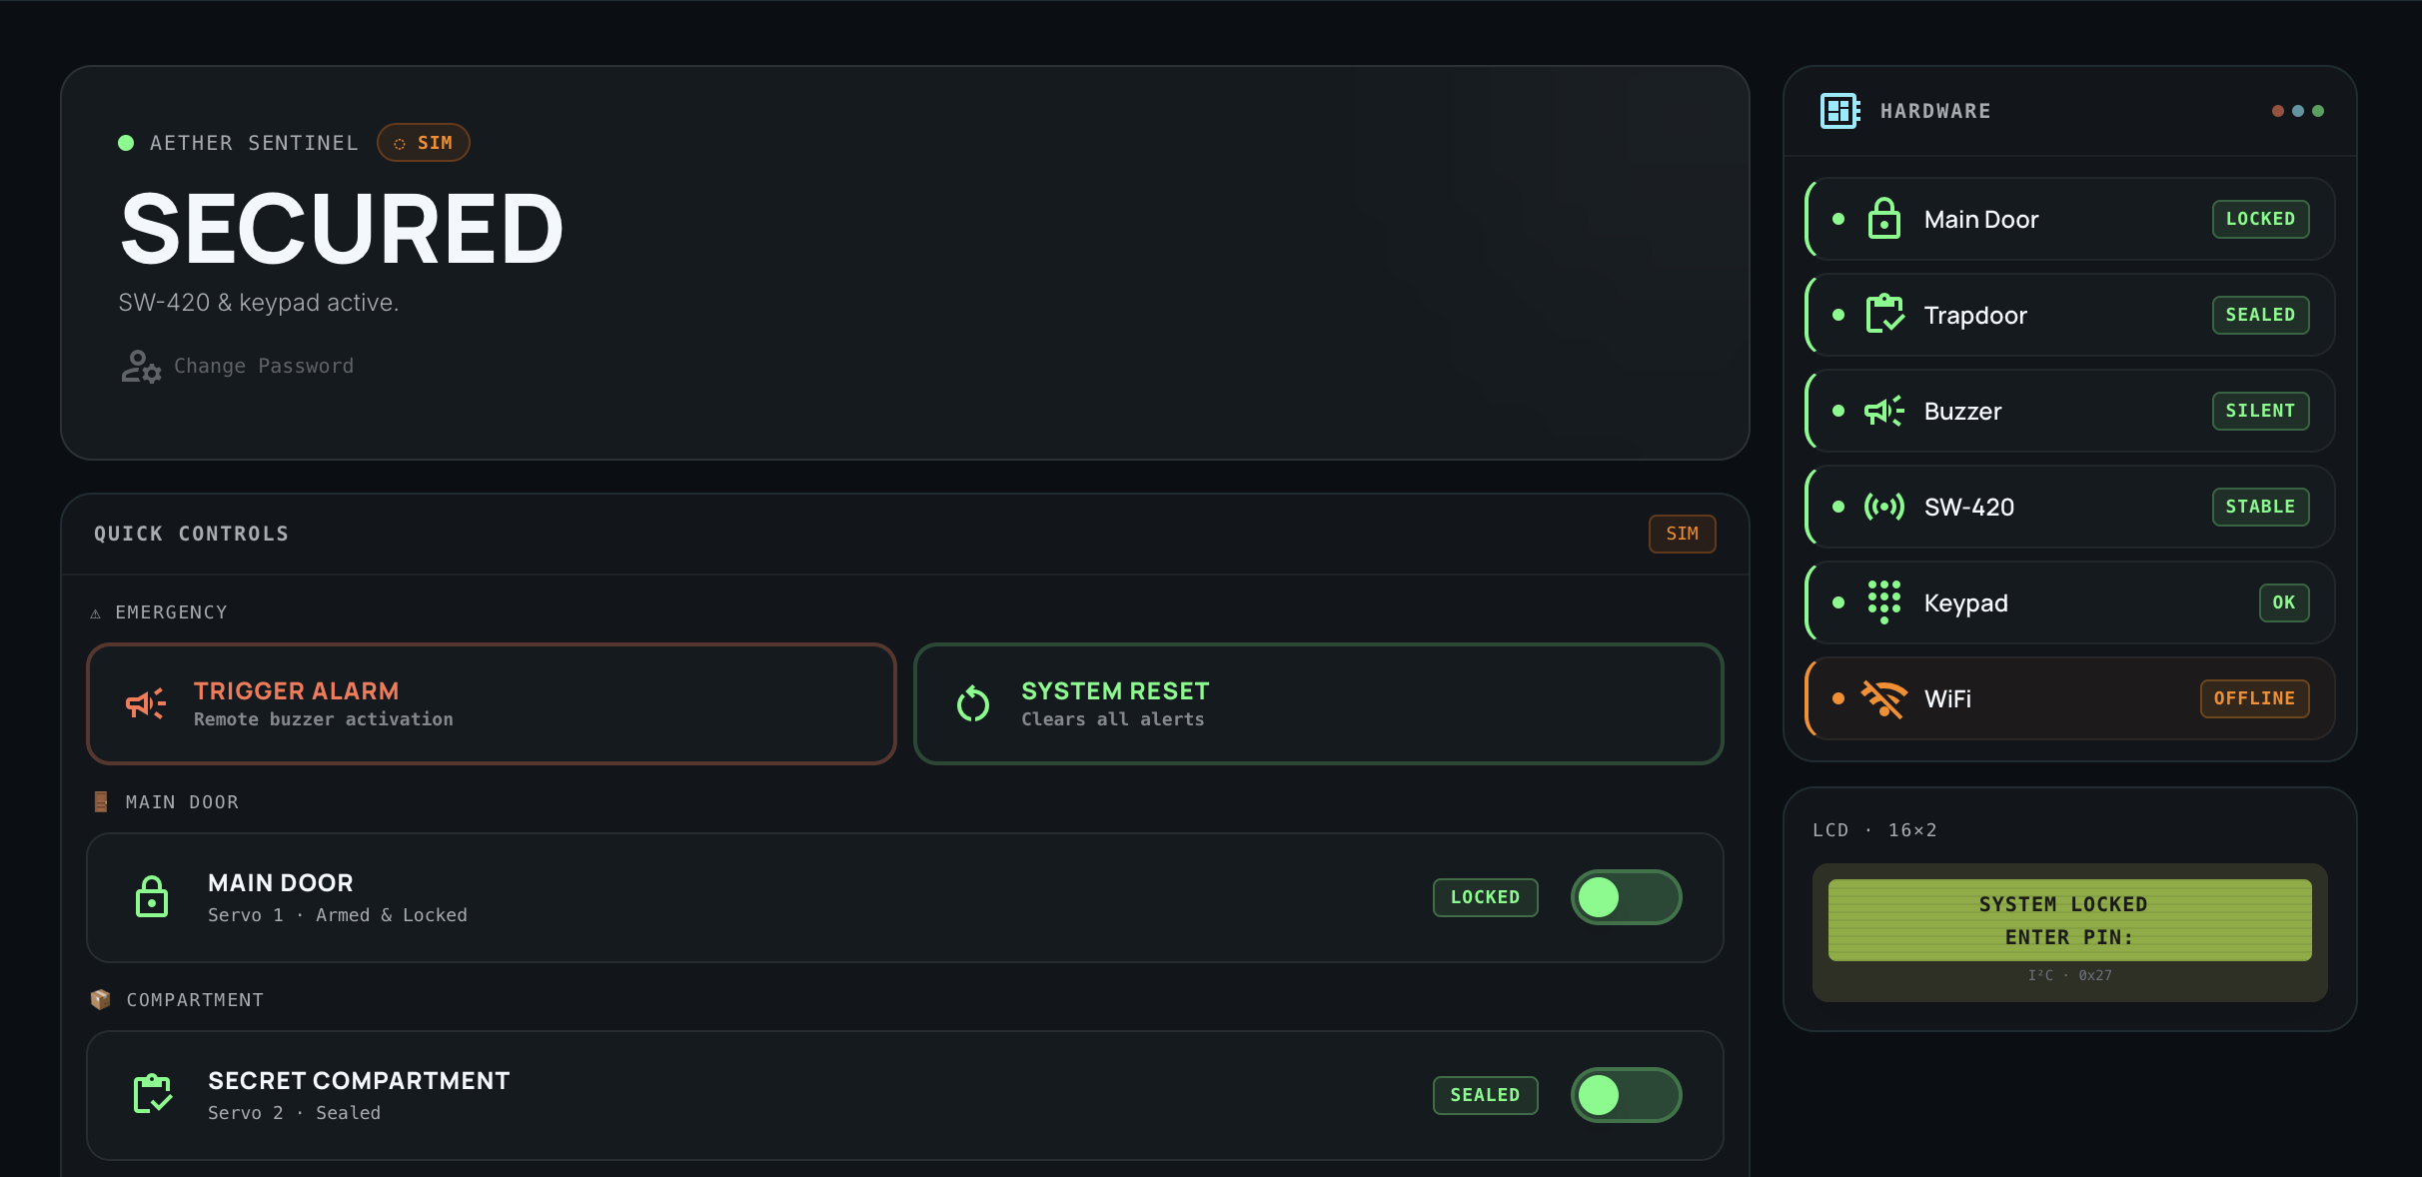
Web-Based Monitoring and Control Dashboard

EXECUTION OF MODEL
The developed prototype was tested under multiple operating conditions to verify system functionality and reliability.
- Correct password entry — locker unlocks successfully
- Incorrect password attempts — alarm and intrusion alerts are triggered
- Vibration/tampering detection — hidden compartment activates and notifications are sent
- IoT communication — real-time updates synchronized with web dashboard
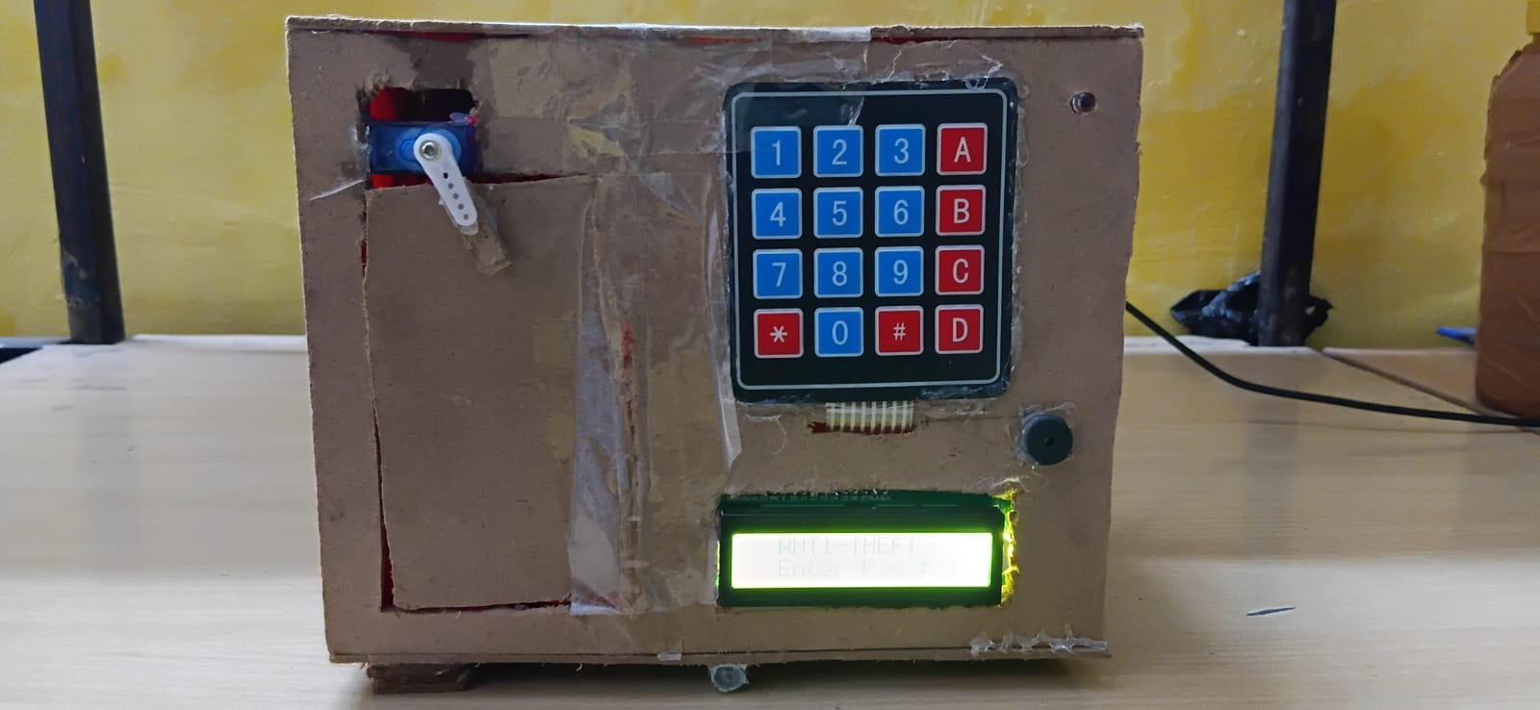
Front View of Developed Smart Locker Prototype

ADVANTAGES
- Improved security over normal lockers
- Real-time alerts to owner
- Password-based access control
- Intrusion detection using sensor
- Automatic locking mechanism
- Low cost and compact design
- Easy to install and maintain
- Suitable for IoT applications

APPLICATIONS
- Home security lockers
- Office and workplace storage systems
- Bank locker security systems
- Jewelry and valuables protection
- Smart hostel and apartment lockers
- IoT-based security applications
- Document and file protection systems
- Industrial equipment storage monitoring
- Personal smart safety lockers
- Educational institution storage systems

FUTURE SCOPE
- Biometric Security — authentication using fingerprint and facial recognition: Future improvements may include integrating AI-based face detection and fingerprint authentication systems to enhance security and automation. These features can provide multi-level user verification, allowing only authorized individuals to access the system. By combining computer vision, biometric authentication, and embedded technology, the project can become smarter, more reliable, and suitable for advanced real-world security applications.
- Mobile App Control — remote system management via smartphone: Enable users to control the locker, change password, and monitor status through a mobile application.
- Cloud Integration — online data storage and access: Use cloud platforms such as Firebase Realtime Database to store logs and manage system data.
- Advanced Sensors — high-precision motion detection: Integrate sensors like MPU6050 for improved and reliable tamper detection.
- Real-Time Alerts — instant notification system: Enhance alert mechanisms using internet-based communication for immediate user notification.
- Power Backup System — alternative energy source: Incorporate battery backup to ensure uninterrupted operation during power failures.
- Multi-Locker System — scalable locker management: Extend the system to manage multiple lockers in institutions such as banks or hostels.
- OTA Updates — over-the-air firmware updates: Allow remote software updates without requiring physical access to the system.

CONCLUSION
The Anti-Theft Smart Locker System with Secret Compartment and IoT Alerts successfully demonstrates a secure and intelligent approach to protecting valuables. The system integrates password-based authentication, vibration-based tamper detection, and an automated secret compartment mechanism to enhance security.
The implementation using a microcontroller (Arduino/ESP32) ensures efficient control of input, processing, and output components such as keypad, sensors, servo motor, and buzzer. The addition of IoT-based alerting enables real-time monitoring and notification, improving responsiveness to potential threats.
Overall, the project achieves its objective of providing a low-cost, reliable, and automated security solution. It also serves as a strong foundation for further enhancements such as biometric authentication, cloud-based control, and advanced intrusion detection systems.

References
- IoT Based Smart Security and Home Automation System, IEEE.
https://ieeexplore.ieee.org/document/8457466
- Smart Door Lock System Using Arduino and IoT, IRJET.
https://www.irjet.net/archives/V7/i5/IRJET-V7I5316.pdf
- Design and Implementation of Smart Locker Security System, IJERT.
https://www.ijert.org/design-and-implementation-of-smart-locker-
security-system
- Home Security System Using IoT and GSM, IEEE.
https://ieeexplore.ieee.org/document/8688545
- Arduino Official Documentation.
https://www.arduino.cc/en/Guide
- ESP32 Documentation by Espressif.
https://docs.espressif.com/projects/esp-idf/en/latest/esp32/
- Firebase Realtime Database Documentation.
https://firebase.google.com/docs/database
- React Official Documentation.
https://react.dev/
- SW-420 Vibration Sensor Module.
https://components101.com/modules/sw-420-vibration-sensor-module
- ESP32 Development Board.
https://www.espressif.com/en/products/socs/esp32
- 16x2 LCD with I2C Module Guide.
https://lastminuteengineers.com/i2c-lcd-arduino-tutorial/

